**8 Questions About Social Security Answered as Election Day Nears**

<https://www.nytimes.com/2018/09/28/your-money/8-questions-about-social-security-answered-as-election-day-nears.html>

*New York Times* - By [Tara Siegel Bernard](http://www.nytimes.com/by/tara-siegel-bernard), Graphic by [Karl Russell](https://www.nytimes.com/by/karl-russell) - Sept. 28, 2018

Every two years, voters — whether they already count on the program, expect to or question paying into it — try to make sense of competing claims about it. It’s that time again.

It’s no wonder that Social Security is politically contentious. The program’s reach is vast: More than 175 million workers contribute to it with every paycheck, and about 43 million retirees collect monthly benefits. For three in five older Americans, those checks account for more than half their income.

Every two years, voters — whether they already count on Social Security, expect to or question paying into the program — must try to make sense of competing claims about it and which lawmakers to entrust it to. This year’s midterm elections are no exception.

Speaking at a rally in Montana this month for a Republican Senate candidate, President Trump [asserted](https://www.nytimes.com/2018/09/14/us/politics/trump-democrats-medicare-social-security.html?rref=collection%2Fbyline%2Fmichael-d.-shear&action=click&contentCollection=undefined&region=stream&module=inline&version=latest&contentPlacement=5&pgtype=collection) that Democrats would “hurt your Social Security so badly.” Most Democrats have suggested preserving or expanding the program. Republicans generally favor scaling it back.

Mr. Trump’s top economic adviser, Larry Kudlow, said in a recent interview that the administration had to be tougher on spending and would begin to consider the “the larger entitlements” — Social Security and Medicare are the two biggest social insurance programs — “probably next year.”

Social Security faces a projected shortfall in about 16 years, when benefits for all recipients — present and future — would be cut by roughly 20 percent. How hard would it be to close the gap, and what plans are there for doing it?

“There remains a great deal of misinformation and misconceptions about Social Security,” said William Arnone, chief executive of the National Academy of Social Insurance, a nonpartisan group of social insurance experts.

Here’s a guide to clear up some of the confusion:

**To what degree do Americans rely on Social Security?**

Signed into law by Franklin D. Roosevelt in 1935, Social Security was created to mitigate the risks for workers in an increasingly industrialized economy. Over time, it came to be seen as one leg of a “[three-legged stool](https://www.ssa.gov/history/stool.html) of retirement” (pensions and savings were the others). With pensions vanishing and the savings rate dismal, millions of retirees now rely on Social Security for a big slice, if not most, of their income.

The average monthly check is $1,413. For about one in three older people receiving benefits, that check accounts for 90 percent of income, [according](https://www.ssa.gov/policy/docs/chartbooks/income_aged/2014/iac14.pdf) to the Social Security Administration.

For one in three retirees who receive Social Security, it accounts for 90 percent of their income. About three in five rely on it for at least half of their income.

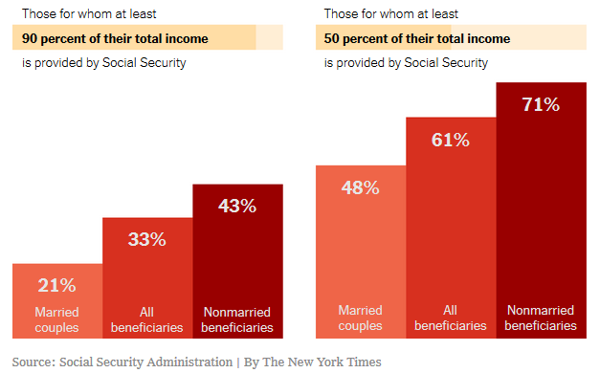

**What’s behind the looming shortfall?**

This year, for the first time since 1982, benefits and administrative expenses are projected to exceed total income. As a result, the program will begin dipping into the reserves in its trust fund. That fund has a $2.9 trillion surplus collected when revenue — most of it from payroll taxes paid by workers and their employers — exceeded costs. The fund will be depleted by 2034, according to the latest [annual report](https://www.ssa.gov/OACT/TR/2018/II_A_highlights.html) from the agency’s trustees. That’s when benefits would fall by 21 percent for everyone.

The shortfall is largely a product of demographic shifts: A large number of baby boomers are collecting Social Security, a declining birthrate is producing fewer workers to pay taxes into the system and retirees are living longer.

Demographic shifts, including a decline in the number of workers paying into the system, are putting stress on Social Security.

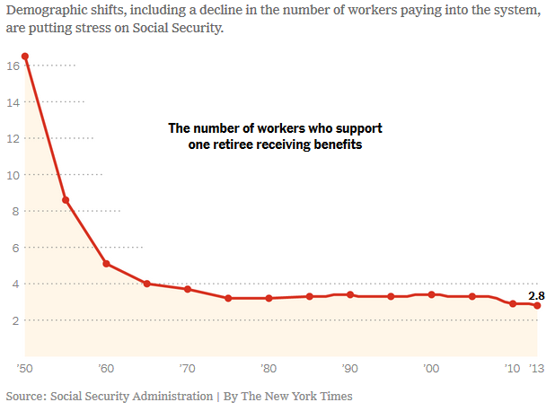

**Does Social Security contribute to the federal budget deficit?**

It depends on whom you ask, but the simple answer is no.

Roosevelt [intended](https://www.ssa.gov/history/genrev.html) the program to be self-sufficient. It has a dedicated revenue source, primarily from those payroll taxes. In many cases, workers split the burden with their employers; each currently pays 6.2 percent on earnings up to [$128,400](https://www.ssa.gov/oact/cola/cbbdet.html), for a total of 12.4 percent. (By law, Social Security, unlike Medicare, cannot use money from the general budget to pay benefits.)

The payroll taxes go into the trust fund. When there is a surplus, the extra money is invested in a special type of Treasury security that pays interest to the trust fund.

Because it is invested in [Treasury securities](http://topics.nytimes.com/top/reference/timestopics/organizations/t/treasury_department/treasury_securities/index.html?inline=nyt-classifier), the money is essentially being lent to the federal government to use however it wants, and must eventually be repaid.

That is where confusion sometimes arises about how Social Security is used to pay for things unrelated to the program. But it is really no different from what happens when the government sells Treasury securities to other investors, like China.

Although Social Security is considered “off budget,” economists and government prognosticators may also view it as part of the so-called unified budget, which includes all federal activities when evaluating everything that affects the economy. From that perspective, Social Security can make the deficit look larger.

**What can be done to close the shortfall?**

There are [various moves](https://www.ssa.gov/OACT/solvency/provisions/summary.pdf) that could shore up the program. Potential fixes generally involve raising taxes, reducing benefits or some combination of the two.

One idea that is often floated is to tax a broader base of workers’ incomes. For instance, the cap on how much income is taxed could be lifted above the current $128,400. Another option would be to raise the tax rate above the 12.4 percent now split between workers and employers.

One way to cut costs would be to raise the age at which workers become eligible for a [full retirement benefit](https://www.ssa.gov/planners/retire/1943.html). This last occurred in 1983, when the age for collecting full benefits gradually rose to 66 and then 67 from 65 (that’s still being phased in now).

**What do Americans support?**

Social Security is one thing most Americans seem to agree on. Polls consistently show that they prize and want to protect their benefits. A [2017 poll](http://assets.pewresearch.org/wp-content/uploads/sites/5/2017/04/24115229/04-24-17-Spending-release.pdf) from the Pew Research Center found that 86 percent of Republicans and 95 percent of Democrats supported maintaining or increasing spending on Social Security.

The median income for retirees who receive Social Security is about $30,000 a year, but about 6 percent earn as little as $5,000 to $10,000; the largest share, about 13 percent, earn $50,000 to $75,000.

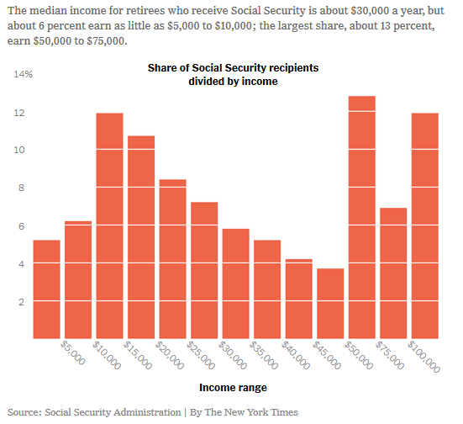

**Where does Congress stand?**

Republicans and Democrats have starkly different ideas, which fall into two broad categories: [Democrats](http://www.presidency.ucsb.edu/papers_pdf/117717.pdf) favor raising revenue through taxes; [Republicans](https://prod-static-ngop-pbl.s3.amazonaws.com/media/documents/DRAFT_12_FINAL%5b1%5d-ben_1468872234.pdf) support measures to reduce benefits, or to at least slow their growth. Experts cite a couple of bills as illustrating the two parties’ general philosophies on the issue.

More than 170 House Democrats, nearly the entire caucus, have [co-sponsored](https://www.congress.gov/bill/115th-congress/house-bill/1902/cosponsors) a [bill](https://larson.house.gov/sites/larson.house.gov/files/LARSON_001_xml%20%283%29.pdf) by Representative John B. Larson of Connecticut [that would](https://larson.house.gov/social-security-2100) generally increase benefits by 2 percent (more for people with lower lifetime income; less for those with higher incomes), set a minimum benefit for low-income earners and adopt a potentially faster-rising [cost of inflation adjustment](https://bucks.blogs.nytimes.com/2010/11/17/debating-social-securitys-cost-of-living-adjustment/) than the one now in effect because it takes into account that older people tend to spend proportionally more on medical care.

[To pay for](https://www.ssa.gov/OACT/solvency/JLarson_20170405.pdf) those changes and for the coming shortfall, the legislation would apply payroll taxes to wages above $400,000 (not indexed for inflation, meaning that, eventually, all earnings would be covered). It would also gradually raise the payroll tax over 24 years by 1.2 percentage points to 7.4 percent for workers and employers.

Although Representative Sam Johnson, Republican of Texas, is retiring, [a bill](https://samjohnson.house.gov/uploadedfiles/social_security_reform_act_bill_text.pdf) he introduced in 2016 includes the [types of changes](https://samjohnson.house.gov/news/documentsingle.aspx?DocumentID=398516) that Republicans typically support. Among other things, it would gradually raise the age at which retirees can claim full benefits to 69.

In practice, that would amount to a significant benefit cut, according to an analysis by [Melissa M. Favreault](https://www.urban.org/author/melissa-m-favreault), a senior fellow at the Urban Institute who studies social insurance programs and models the effects of different policy changes. Based on the Social Security Administration’s actuaries’ [review](https://www.ssa.gov/oact/solvency/SJohnson_20161208.pdf) of Mr. Johnson’s proposal, Ms. Favreault calculates that a retiree would either have to forgo two years of benefits, or receive a check that was 13.3 percent smaller at 67. This change would affect people born in 1968 and later. Those born from 1961 to 1967 would see smaller cuts. (Mr. Johnson’s office confirmed the accuracy of Ms. Favreault’s calculations.)

Mr. Johnson’s proposal would also change the benefit formula so that higher-than-average earners would receive less while the lowest earners got more. Another provision would cut benefits for people who had more variable earnings or people who spent long periods not working, Ms. Favreault said. The plan also proposes using a [cost-of-living adjustment](https://www.nytimes.com/2013/04/20/your-money/the-potential-effect-of-obamas-social-security-proposal.html?ref=business&_r=0&module=inline) that grows more slowly, and the creation of a minimum benefit.

**Has the Trump administration taken steps that affect Social Security?**

A couple of relatively recent actions would hurt the trust fund slightly over the next decade, but would have a negligible long-term effect. The [tax law](https://www.nytimes.com/2017/12/16/business/the-winners-and-losers-in-the-tax-bill.html?module=inline) enacted last year has a “significant net negative effect” over the next 10 years, according to the 2018 annual trustees’ report, and the proposed [elimination](https://www.nytimes.com/2017/09/05/us/politics/trump-daca-dreamers-immigration.html?module=inline) of the Deferred Action for Childhood Arrivals, or DACA, program, would also reduce program revenue.

**What are the prospects for an agreement that fixes the program?**

The last time Congress made [significant adjustments](https://www.ssa.gov/history/1983amend.html) to close a shortfall, in 1983, both Democrats and Republicans had to make concessions. Some policy experts said they believed the parties were more polarized now, making such an agreement more difficult.

“It will require some very substantial give by both parties to make it happen,” said [Charles Blahous,](https://www.mercatus.org/charles-blahous) a senior research strategist at the Mercatus Center at George Mason University.

The sooner that giving starts, experts agree, the less drastic the changes will need to be.

Doris Burke contributed research.

**Excerpt from the 2016 Democratic Party Platform**

***Protecting and Expanding Social Security***

Democrats are proud to be the party that created Social Security, one of the nation’s most successful and effective programs. Without Social Security, nearly half of America’s seniors would be living in poverty. Social Security is more than just a retirement program. It also provides important life insurance to young survivors of deceased workers and provides disability insurance protection. We will fight every effort to cut, privatize, or weaken Social Security, including attempts to raise the retirement age, diminish benefits by cutting cost-of-living adjustments, or reducing earned benefits. Democrats will expand Social Security so that every American can retire with dignity and respect, including women who are widowed or took time out of the workforce to care for their children, aging parents, or ailing family members. The

Democratic Party recognizes that the way Social Security cost-of-living adjustments are calculated may not always reflect the spending patterns of seniors, particularly the disproportionate amount they spend on health care expenses. We are committed to exploring alternatives that could better and more equitably serve seniors.

We will make sure Social Security’s guaranteed benefits continue for generations to come by asking those at the top to pay more, and will achieve this goal by taxing some of the income of people above $250,000. The Democratic Party is also committed to providing all necessary financial support for the Social Security Administration so that it can provide timely benefits and

high-quality service for those it serves. Our plan contrasts starkly with Donald Trump. He has referred to Social Security as a “Ponzi scheme” and has called for privatizing it as well as increasing the retirement age.

**Excerpt from the 2016 Republican Party Platform**

***Saving Social Security***

We reject the old maxim that Social Security is the “Third Rail” of American politics, deadly for anyone who would change it. The Democratic Party still treats it that way, even though everyone knows that its current course will lead to a financial and social disaster. Younger Americans have lost all faith in the program and expect little return for what they are paying into it. As the party of America’s future, we accept the responsibility to preserve and modernize a system of retirement security forged in an old industrial era beyond the memory of most Americans. Current retirees and those close to retirement can be assured of their benefits. Of the many reforms being proposed, all options should be considered to preserve Social Security. As Republicans, we oppose tax increases and believe in the power of markets to create wealth and to help secure the future of our Social Security system. Saving Social Security is more than a challenge. It is our moral obligation to those who trusted in the government’s word.

**Mitch McConnell Calls for Social Security, Medicare, Medicaid Cuts After Passing Tax Cuts, Massive Defense Spending**

<https://www.newsweek.com/deficit-budget-tax-plan-social-security-medicaid-medicare-entitlement-1172941>

*Newsweek* - BY [Nicole Goodkind](https://www.newsweek.com/authors/nicole-goodkind) – October 16, 2018

After instituting a $1.5 trillion tax cut and signing off on a $675 billion budget for the Department of Defense, Senate Majority Leader Mitch McConnell said Tuesday that the only way to lower the record-high federal deficit would be to cut entitlement programs like Medicare, Medicaid and Social Security.

"It’s disappointing, but it’s not a Republican problem," McConnell said of the deficit, which grew 17 percent to $779 billion in fiscal year 2018. McConnell explained to Bloomberg that "it’s a bipartisan problem: Unwillingness to address the real drivers of the debt by doing anything to adjust those programs to the demographics of America in the future." The deficit has increased 77 percent since McConnell became majority leader in 2015.

New Treasury Department analysis on Monday revealed that corporate tax cuts had a significant impact on the deficit this year. Federal revenue rose by 0.04 percent in 2018, a nearly 100 percent decrease last year’s 1.5 percent. In fiscal year 2018, tax receipts on corporate income fell to $205 billion from $297 billion in 2017.

Senate Majority Leader Mitch McConnell speaks as President Donald Trump looks on during a 'Make America Great Again' rally at Eastern Kentucky University, in Richmond, Kentucky, on October 13. The deficit has increased 77 percent since McConnell became majority leader in 2015.NICHOLAS KAMM/AFP/GETTY IMAGES

Still, McConnell insisted that the change had nothing to do with a lack of revenue or increased spending and instead was due to entitlement and welfare programs. The debt, he said, was very “disturbing” and driven by “the three big entitlement programs that are very popular, Medicare, Social Security and Medicaid.… There’s been a bipartisan reluctance to tackle entitlement changes because of the popularity of those programs. Hopefully, at some point here, we’ll get serious about this.”

President Donald Trump promised to leave Medicare untouched on the campaign trail, but Republican leaders like House Speaker Paul Ryan and Florida Senator Marco Rubio have long indicated their desire to cut entitlement programs to pay for their tax cuts.

"You have got to generate economic growth because growth generates revenue,” Rubio said at a Politico conference late last year. "But you also have to bring spending under control. And not discretionary spending. That isn’t the driver of our debt. The driver of our debt is the structure of Social Security and Medicare for future beneficiaries."

“We're going to have to get back next year at entitlement reform, which is how you tackle the debt and the deficit,” Speaker Ryan said on a conservative radio program around the same time.

Democrats, meanwhile, jumped on McConnell’s admission as proof that Republicans had long planned to cut entitlement spending to fund the tax cuts that largely benefit corporations and wealthy Americans. “The truth comes out! This was their deceptive plan all along,” said Representative Lois Frankel of Florida.

“When Republicans in Congress said their tax cuts to wealthy multinational corporations would pay for themselves, they lied,” wrote Ohio Congressman Tim Ryan on Twitter. “Now, they're going to try to come for hardworking people to foot the bill by slashing Medicare, Medicaid, and Social Security. We can't let them.”

A recent Pew poll found that the majority of both Democrats and Republicans thought the rising federal deficit and cost of health care were major problems facing the U.S.—something that Democrats are taking note of and will try to package into their midterm campaign platforms over the next three weeks.

“Every Republican Senate candidate is on the hook for Mitch McConnell’s plan to cut Medicare and Social Security. First it was jeopardizing pre-existing conditions coverage, then it was pursuing an age tax that would charge older Americans more for care, and now it’s targeting the benefits Americans have paid into,” wrote Democratic Senatorial Campaign Committee spokesman David Bergstein in a statement. “This platform is disqualifying, and just like taking away coverage for pre-existing conditions, it's exactly what GOP candidates don't want to be talking about weeks before the election.”